ADM Knowledge Base with ORM stack

Contents

1. Introduction 3
2. Workflow diagram to deploy the stack 3
3. Create stack for the ADM knowledge base 4
4. Plan the Job 6
5. Apply the Job 7
6. Verify in the Console 8
7. Destroy the stack 9

Introduction

ADM provides a graphical representation of the dependencies, allowing to visualize the relationships between resources. This can help understand the flow of data and interactions between different components of application.
This resource provides the Knowledge Base resource in Oracle Cloud Infrastructure Adm service.

Workflow diagram to deploy the stack

Below diagram shows how the Terraform Artifact are applied in the OCI. While creating a ORM stack, using terraform deliverables Init, Plan and Apply is the flow to provision the resource in the OCI. We can have the deliverables in any of below.

- GitLab/GitHub Repo
- Bitbucket
- Can be in folder/.zip in the local disk
- Object Storage Bucket
- Can be in compartment
- Oracle provided Template


Create stack for the ADM knowledge base

Go to OCI Console Developer Services Resource Manager Stacks select the compartment Create Stack

My Configuration Folder Browse Select the “ADM_knowledge” folder that contains the terraform Upload

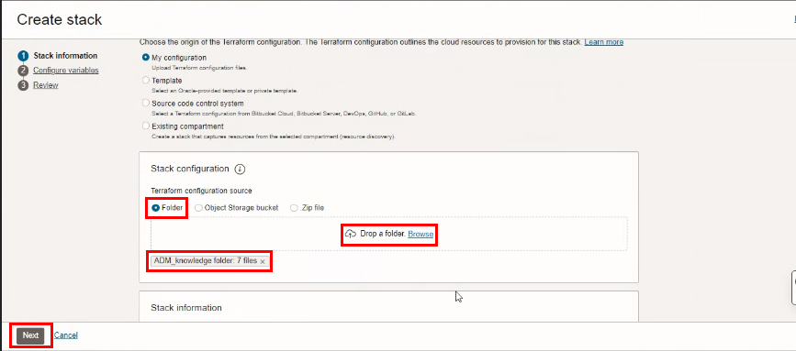

Select the parameters as per the below screen,
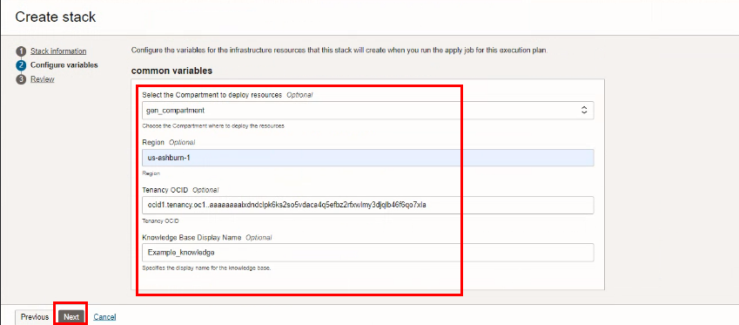

Click “NEXT”
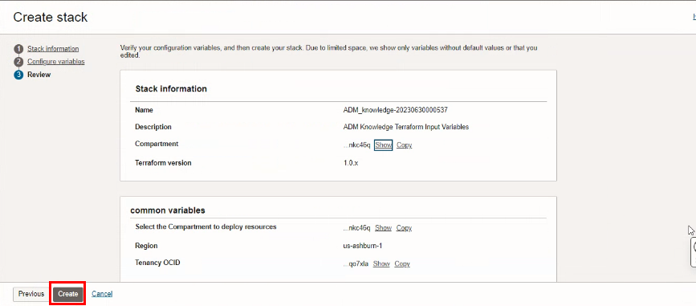
Click “CREATE”

Plan the Job
Click the “Plan”

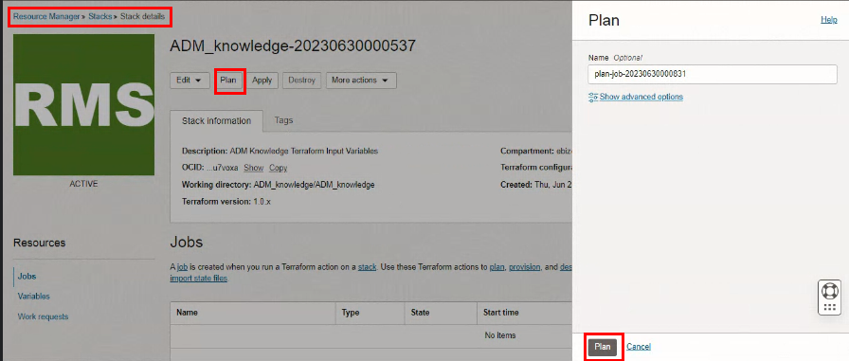

Verify the Plan is successful.

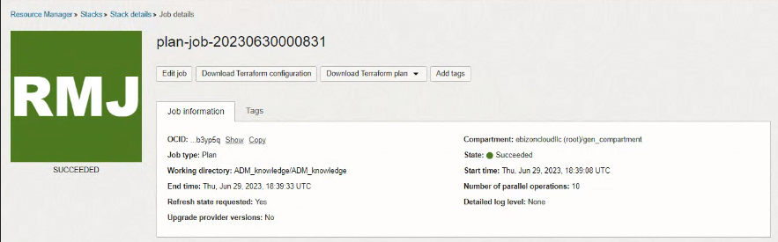

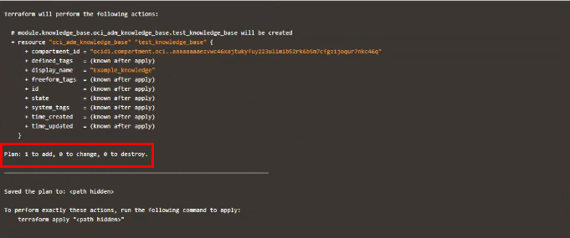

Apply the Job

Once the “plan” is success, now click “Apply”

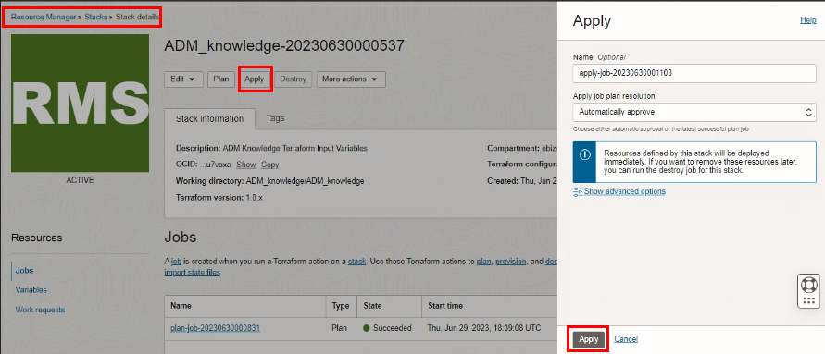

Verify the Apply is successful.
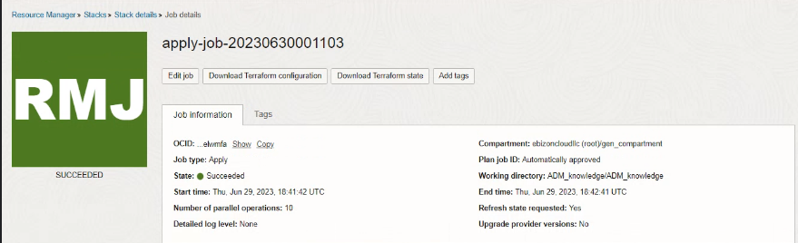

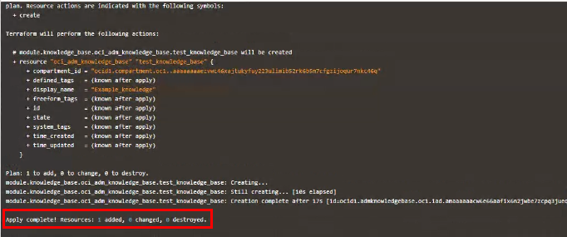

Verify in the Console

Go to OCI Console Developer Services App Dependency Management Knowledge bases
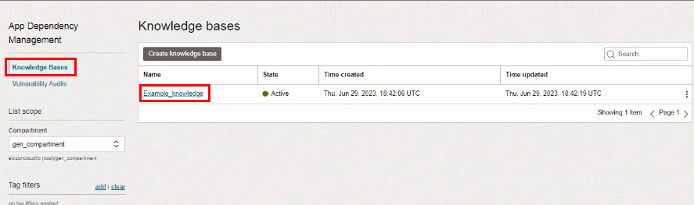

Go to OCI Console Developer Services App Dependency Management Knowledge bases Knowledge bases details

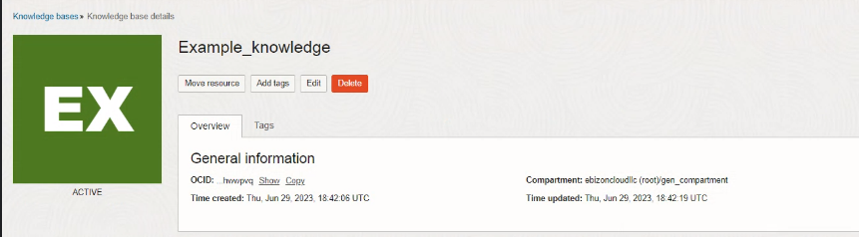

Destroy the stack

Create a destroy job in Resource Manager to release resources associated with a stack and clean up the tenancy. Once destroyed data cannot be recovered from resources.

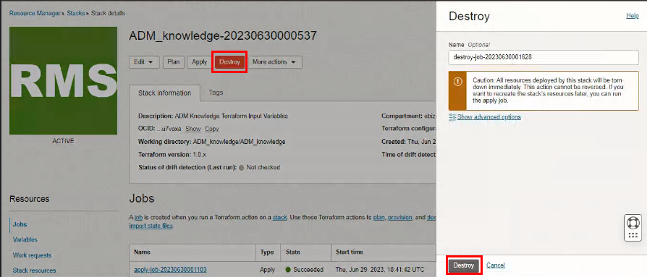

# END #

